**INTRODUCTION**

European Associate Membership is for climbing walls based with the EU outside of the UK and Ireland, who wish to use the ABC standard guidelines to inform their good practice. **The European Associate membership is ‘information’ only: we do not offer any advice to walls outside of the UK laws and the ABC does not take responsibility for any regional differences in regulation or other matters.**

Membership is valid for 12 months from successful application at a cost of €540 p.a.*

* You must supply your VAT number to qualify for this price and then account for VAT via the reverse charge obligation in your own country. If you are **not** registered for VAT in your country, then we will need to add UK VAT (20%) to the membership fee. Payment is required via bank transfer.

European Associate membership will give you:

* Access to the industry standard ABC Operational Guidelines. These are based on BS-EN standards and are checked over by Technical Advisors and Barristers.
* Discounted tickets to the annual ABC Conference & AGM
* Opportunity to attend relevant online seminars
* Invitations to working groups (subjects range from auto belay safety to panel strength assessment)
* Industry-relevant newsletters (roughly twice per month, but we make sure only to send newsletters when we have something useful to say).
* Safety self audit form
* Member downloads, which include; boulder safety and safe belaying posters (some member downloads may be less relevant to international members due to variances in regulations e.g. risk assessment templates, acknowledgment of risk forms, accident procedure form templates. Use of these would be at the member’s discretion)

**USING THIS DOCUMENT**

Please complete all sections of the form and send to [admin@abcwalls.co.uk](mailto:admin@abcwalls.co.uk) when complete. Please contact us if you have any questions while completing the form.

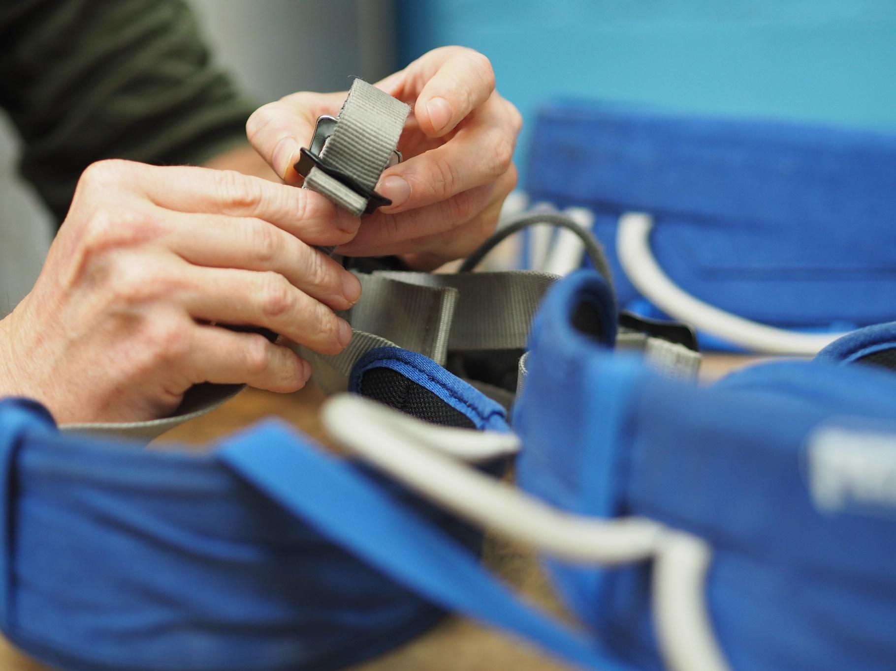

| **WALL INFORMATION** |  |
| --- | --- |
| Wall name |  |
| Company name |  |
| Wall address |  |
| Telephone number |  |
| Wall contact email address |  |
| Wall website |  |
| Wall type (delete as appropriate) | Bouldering / Roped climbing / Mixed |
| Is the wall already operational? | Yes / No |
| If no, at what stage is your project? |  |
| When do you expect to open? |  |
| What activities do you offer / will you offer?  (Delete/add as appropriate) | Bouldering  Top roping  Lead climbing  Auto belay  Dedicated training area  Clip and Climb  Other (specify) |
| Are you / will you open to the general public? | Yes / No |
| Approximate size of climbing areas (by number of problems or lines)  e.g. ~100 boulder problems and ~top rope lines | Bouldering:  Top roping:  Lead climbing:  Auto belay: |
| **CONTACT INFORMATION** |  |
| Main contact name |  |
| Main contact email address |  |
| Main contact phone number |  |
| Position in company |  |
| Second contact name (optional) |  |
| Second contact email address |  |
| Second contact phone number |  |
| Position in company |  |
| **BILLING INFORMATION** |  |
| Full Business Name |  |
| Business Address |  |
| Email address |  |
| VAT number |  |
| Other Invoice details (e.g. PO number) |  |
| **OTHER INFORMATION** |  |
| How did you hear about the ABC? |  |
| Social media accounts (if you want to connect) |  |

The ABC communicates with our members via email newsletter about our guidelines documents, upcoming seminars and events, safety updates and product recalls, the ABC conference, and other ABC and industry news.

Please select one of the following:

|  | X |
| --- | --- |
| I consent to receive newsletter updates from the ABC, please add the contact email address(es) above to the ABC mailing list. |  |
| I do not consent to receive updates. I do not want to receive notification of new guidelines documents, upcoming seminars, safety updates, the ABC conference, or any other ABC and industry news. |  |

**Declaration**

By submitting this form, I am making the following declaration:

* I am applying for European Associate Membership of the ABC on behalf of the organisation named above.
* I understand that the ABC does not provide advice to walls outside of UK laws and that this membership is ‘information only’.
* We will not give copies of the ABC’s Guidelines or any other documents produced by the Association to 3rd parties without the consent of the ABC.
* I consent to receive necessary communications about my membership from the ABC
* I request an invoice to be sent to my billing email address